Recovery Time and Point Objectives

**Eastern Cape Department of Education -- Digital Learning Environment**

# Recovery Time Objectives (RTO)

Recovery Time Objectives define the maximum acceptable time to restore a system after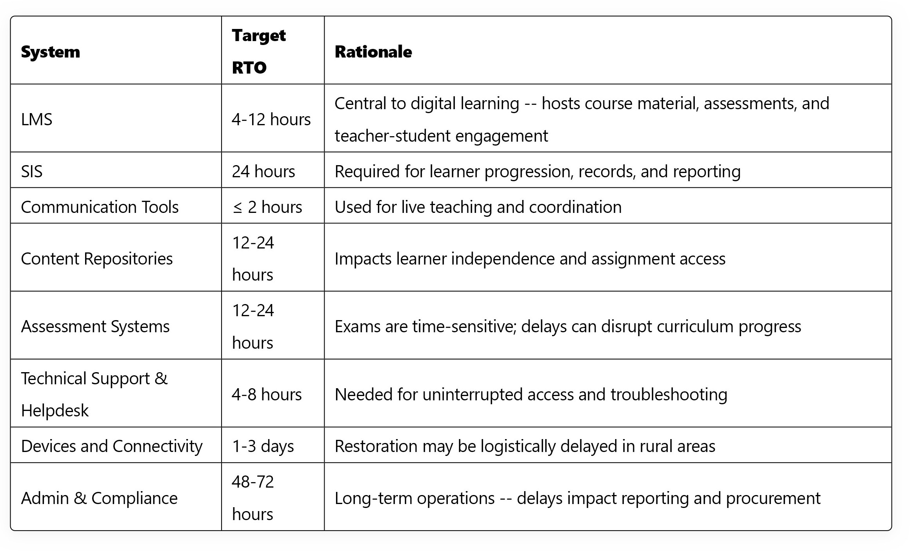 disruption.

# Recovery Point Objectives (RPO)

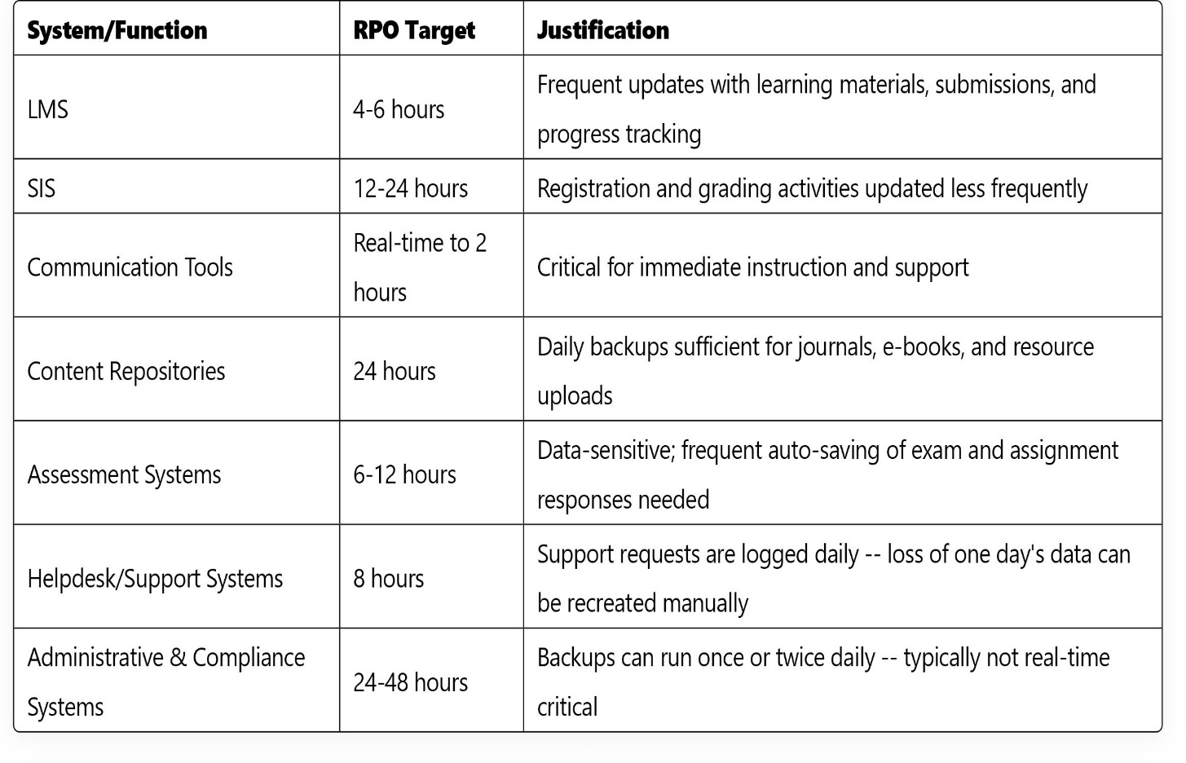Recovery Point Objectives define the maximum acceptable amount of data loss measured in time.